Game Design Document

Fill up the following document

1. Write the title of your project.

Universal “Game”

1. What is the goal of the game?

Aliens have to destroy the spaceship along with asteroids

1. Write a brief story of your game.

Humans are trying to discover in space,but eventually find aliens living

In asteroids they attack the spaceship as humans enter in their

Environment which leads the humans to die and die trying

1. Which are the playing characters of this game?

* Playing characters are the ones who respond to the user based on the input from the user.
* Cars, monkeys, dinos, wizards, etc., are the playing characters in the game.

|  |  |  |
| --- | --- | --- |
| Number | Character Name | What can this character do? |
| 1 | alien | Try to kill humans |
| 2 | Asteroid | Stone |
| 3 | Humans | Die trying themselves |
| 4 | Spaceships | Shoots bullets and escapes |
| 5 | Earth | object |
| 6 | Bullets | Alien object |
| 7 | Satellite | Object |
| 8 |  |  |

1. Which are the Non-Playing Characters of this game?

* Non-Playing characters are the ones that don't have an action or behavior when the user interacts with the game.
* Hurdles, stones, bananas, coins, etc., are non-playing characters in the game.

|  |  |  |
| --- | --- | --- |
| Number | Character Name | What can this character do? |
| 1 | Background | Object |
| 2 | Rank | Increases/decreases |
| 3 | Points |  |
| 4 | Stars |  |
| 5 | Galaxy |  |
| 6 | Space | Fight occurs here |
| 7 | walls | Object |
| 8 |  |  |

Draw your imagination of this game. What does this game look like?

* Draw the game either on your computer or on paper.
* Add images of the game scenes to show each of the playing and non-playing characters at least once.

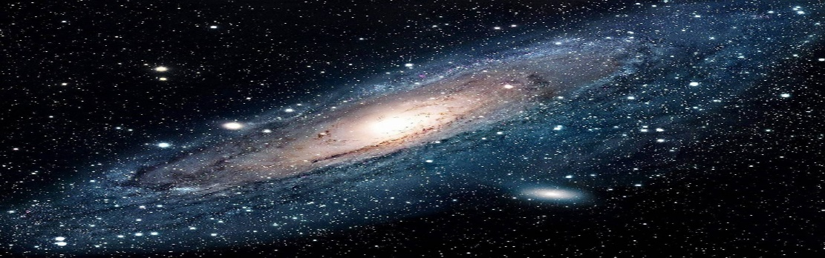

How do you plan to make your game engaging?

The spaceship has to escape the asteroid which are been attacked by the aliens as it escapes the point for spaceship increases.When it gets destroyed alien point increases